Kwame Acheampong & Brian Sun  
System Context Diagram, Container Diagram, & Component Diagram for URLmanager.py  
  
System Context Diagram:  
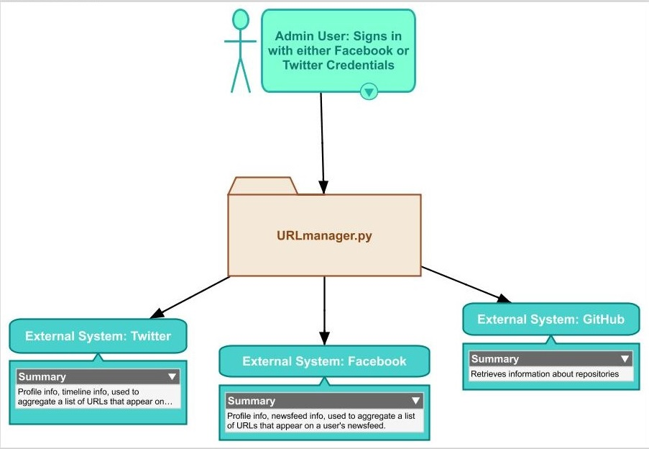

Container Diagram:

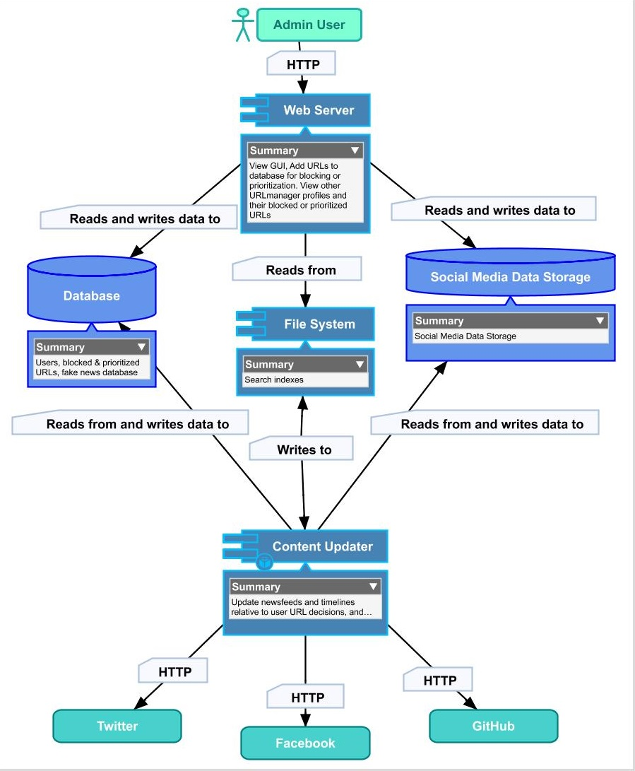

Component Diagram:

